ID: 217 E
Smart Energy Management Systems
Latest Developments of CCPP in Europe as Renewables Backup
Andreas Mueller
Siemens Energy, Germany
a.mueller@siemens-energy.com +4915222936470
A new class of highly efficient Combined Cycle Power Plants has now established a new standard for efficient, all-time-available and flexible energy generation as backup for renewables in Europe, while minimizing the CO2 emission acc. to latest EU regulation.
This paper introduces the audience to the latest developments in Europe and discusses how this new generation of gas fired power plants can also be a solution for Israel's changing energy landscape, to secure energy supply in times of increasing share of renewables and growing electricity demand, while at the same time significantly reducing Israel's CO2 footprint.
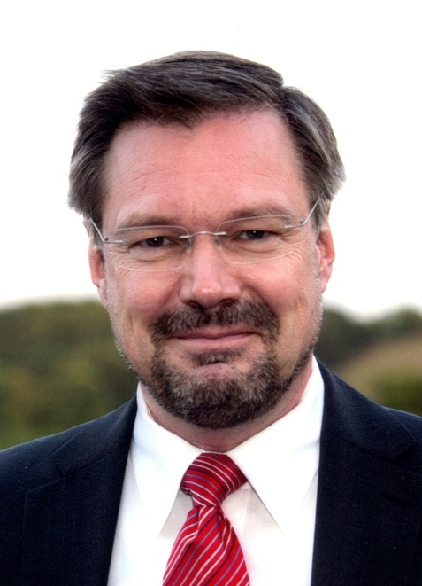
Sales professional in Siemens Energy for large combined cycle power plants for the last 18 years; more than 10 years in Israel.:

