ID: 198 E
Renewable Energies Methods and Innovations
Rolls-Royce Energy Solutions – Microgrid
מערכת אנרגיה מתחדשת
Markus Schaefer
Rolls-Royce Solutions, Germany
Markus.Schaefer@ps.rolls-royce.com +49 7541 90-7068 +49(176)17900473
A Microgrid is a Decentralized Energy System consisting of any combination of Renewable Energy generation, Conventional Energy generation and Energy Storage to satisfy a given Load in an Off-Grid or Grid-Tied setting
A Microgrid Controller is in place to manage the entire system operation.
The MTU product portfolio is designed to optimally combine with renewable energy sources, in order to make your microgrid tick.
Design of an EnergyPack QL Compact and modular design Up to 23 battery racks
Various product options
• Part redundancy
• Internal transformer
• Corrosion protection class C5M
• Fire suppression system
• Reduced noise emission
• UL conformity
A few Grounding Terminology: Battery Applications
Key Facts
• Highly flexible test environment, modular set-up
• Development and validation of new control algorithms and technologies
• Simulation of customer requirements in a real environment
• Possibility to emulate different load and generation profiles
• Validation of techno-economic models, from components and entire microgrids
• Island & Grid-parallel operation
• Cost and CO2 savings for FN Plant 1
• Extendable
Tangible benefits for manufacturing plant
• Power & Heat
• Peak shaving
• Reduce energy demand from grid
• Cost saving
• Integration of PV, reduce CO2 emissions
• Grid services
MicroGrid Control Architecture
Specific OEM Interfaces
Fast Developments for new OEMs Large, Flexible and Expandable Device Library
• GenSets
• PV Converters
• BESS
• Metering Devices
Q Grid / Utility Solutions
• For projects with a capacity > 4,4 MWh
• Tailoring of base units for project specific power and capacity needs
• Scaling of base units to project size
• Max. 12 battery racks per inverter input
• Available Q1/2022
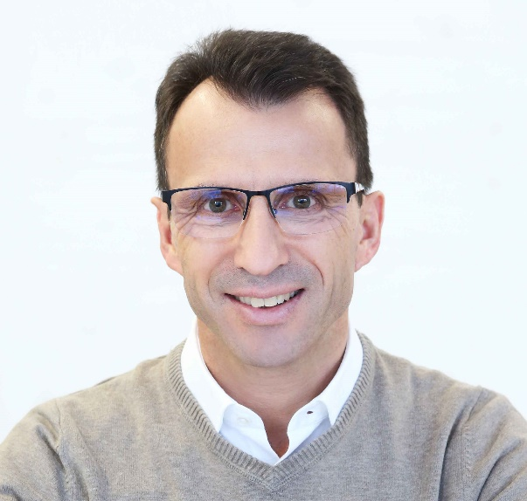
1989-1997: MTU-Friedrichshafen GmbH - Marketing Marine Application
1997-2009: MTU-Friedrichshafen GmbH - Sales PowerGen Asia
2009-2018: MTU-Friedrichshafen GmbH - PowerGen Projects Nuclear Europe
2018-today: Rolls-Royce Solutions GmbH – Sales PowerGen Western Europe

