ID: 44 E
Renewable Energies Methods and Innovations
Isolated DC-DC Converters for Safe Battery Energy Storage Systems
Dr. Andei Drozdov
Solcon Industries, Israel
dina.s@solcon.com 054-7725364
Safety is one of the main requirements when installing large-scaled energy storages.
An installation would have several series-parallel connected batteries and there is a huge short-circuit current. If there were to be any decrease in insulation or perhaps a DC pole short circuit to the ground, turning off all associated DC equipment would immediately be required to avoid the fuse failures that would occur in the event of a second pole short circuit.
Identifying a specific point pole-to-earth fault is a lengthy process, that can only be carried out by qualified personnel, during which all the DC devices are checked sequentially by connecting them to the DC bus and monitoring the level of isolation. During this time, the installation cannot operate and must be shut down.
I present a solution that shows the division of the power on the DC bus into sections by way of isolated bidirectional DCDC converters, that would perform the function of electrical isolation, thus combining 3 important functions of power control, protection in addition to DC breaker. A combination of modules in parallel that would provide up to 2MW of power, at a current of 2500A and a voltage of 800V, which is ideal for building up electrical energy storage in the range of up to 20MW, leaving it possible for a conventional LV-inverter and transformer to then integrate the energy into the AC network.
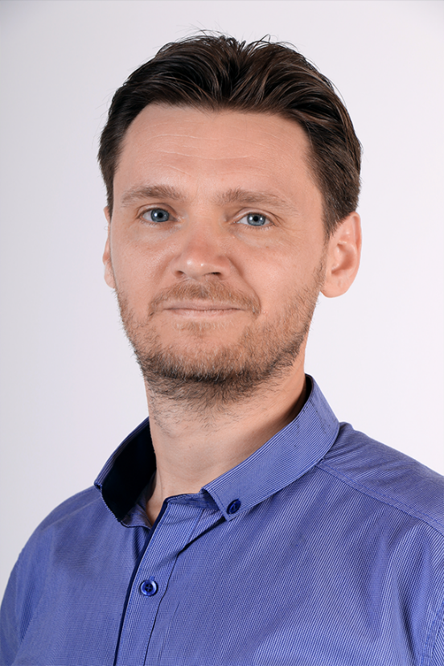
Dr. Andrei Drozdov is a self-motivated researcher and leader in the field of grid-tied converters, motor control, embedded control system and LV/MV power electronics design.
He received his PhD degree from the Automated Electric Drives department in MPEI (Moscow Power Engineering Institute), focusing on field-oriented control for different types of motors and designing fail-safe control systems.
Over the years Andrei has built experience and knowhow in the field of MV converters for grid and power utilities, by leading many R&D projects with designs related to FACTS, smart grids and the area of HVDC. This includes his major contribution in the design, testing and commissioning of the high-performance MCU/FPGA base control and protection of MV converters with stacked IGBT. Being responsible for numerous applications of MV SVC, CSRT, STATCOM and grid-tied B2B converters that were installed and put into operation in the Russian electrical grid, that has expanded and is widely used to this day, all the time accumulating deep knowledge in energy generation utilities, transmission lines operations, and a variety of load profiles on the side of the consumer.
Today, Andrei is Solcon-IGEL Group’s VP of R&D, stationed in the group’s headquarter in Yokneam and leading the design and development of the group’s power electronics products that is destined to bring about a highly needed improvement to the clean energy technologies used today.

