ID: 42 H
Equipment Maintenance & Renewal
Cost-effective MV/LV Switchgear Modernization Solutions
פתרונות לחידוש לוחות חשמל מתח גבוה ומתח נמוך
Albert Shtaif
Afcon Manufacturer, Israel
Alberts@afcon.co.il 052-5524322
Cost-effective switchgear modernization solutions.
Conversion method, roll-in replacement circuit breaker, hard-bus or cradle-in-cradle Retrofit; which one to choose in order to achieve a noticeable improvement on reliability, safety, maintenance and performances?
Retrofit solution
Retrofit means the implementation of modern components in the existing MV installation with following benefits:
Cheaper than a complete replacement, minimum shutdown of the switchboard, remaining service life extension, minimization of further maintenance costs, spare parts availability for long time.
Retrofit solution Description Benefits
Conversion The conversion method utilizes the existing circuit breaker truck together with some portion of the existing parts, to build a new device that interfaces with the existing switchgear. This concept gets most of the benefits of roll-in retrofit, but the reuse of some parts result in a more cost effective solution. It requires additional inspection and testing activities to ensure those parts will not compromise the equipment reliability
Roll-in replacement The roll-in replacement circuit breaker is a completely new device built around a modern fixed assembly. A properly designed replacement circuit breaker is fully interchangeable with the existing one. Active Standards compliance is the key element when designing replacement breakers. This methodology allows to exchange the original device without downtime required for the switchgear replacement.
Retrofit solution
Retrofit is a process including the replacement of circuit breaker with complete cassette.
Retrofit solution Description Benefits
Cradle-in-cradle Is a complete cassette with inner and outer interfaces. The outer interface mounts physically and electrically in the switchgear cubicle Type tested solution according to latest IEC 62271 -1 and 100 Standards.
Interchangeable equipment with new extension panels and additional switchgear
Reusable apparatus in replacement switchgear.
Hard-bus Retrofit
Is composed by a frame hosting the circuit breaker . OneFit is the ABB hard-bus Retrofit design concept, to a wide range of existing panels.

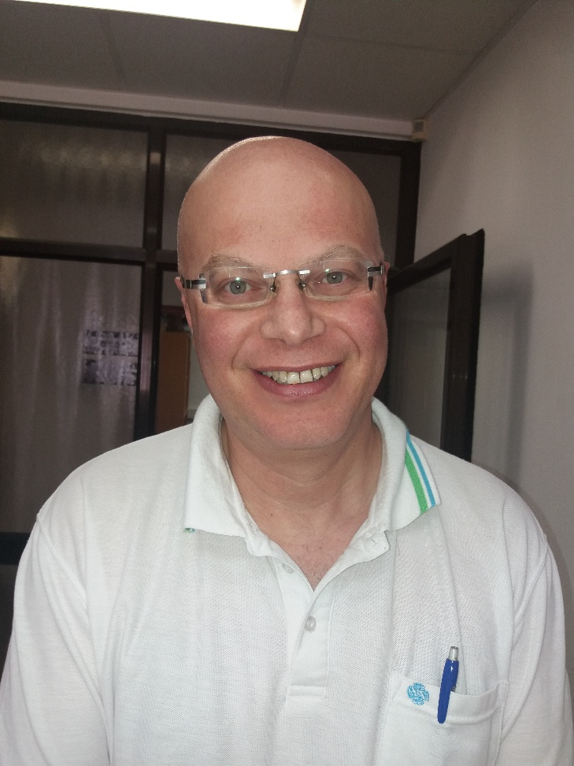
שטייף אלברט
טלפון : 08-8670045
טלפון נייד : 052-5524322
השכלה: מהנדס חשמל
לימודים:
1986-1991 לימודים במכון הפוליטכני ע"ש ס. לזו בעיר קישינב. תואר שני בהנדסת חשמל
התמחות באספקת חשמל למפעלי תעשיה, ערים, וחקלאות.
ניסיון מקצועי:
05.13 עד היום סמנכ"ל שיווק ומכירות , מפעליות Afcon .
05.98-05.13 מהנדס חשמל בכיר במחלקת מכירות , מפעל מיתוג של סימנס ישראל .
02.96-05.98 מהנדס חשמל בתחום מכירות , פויכטונגר תעשיות בע"מ , מפעל לייצור לוחות חשמל.
01.94-02.96 מהנדס חשמל בתחום התכנון, משרד יועצי חשמל קראל ולנט מהנדסים.

