ID: 131 H
Inspection in Electrical Facilities
VLF Cable Testing, Measurement and Analysis of Partial Discharges
בדיקות כבלים בתדר נמוך מאוד, מדידה וניתוח של פריקות חלקיות
Boris Aizenberg
A.Lozdernik Engineering, Israel
borisaiz@alozdernik.com 053-7705130
VLF cable testing, performed at a very low frequency of 0.01 Hz to 0.1 Hz, is a standardized and up-to-date method determining the condition of the cables in MV and HV networks. Compared to standard DC testing, it prevents damage to the insulation of aged extruded cables (typically XLPE) which causes a premature loss.
DC hipot testing has been also found ineffective in detecting serious defects. Due to these reasons, VLF AC waveform testing is recommended.
Partial Discharge Measurement and Analysis on Power Transformers
Partial discharges (PD), as defined by IEC 60270, are localized dielectric discharges in a partial area of a solid or liquid electrical dielectric insulation system under high-voltage field stress. Partial discharges in a transformer deteriorate its insulation and can lead to failure
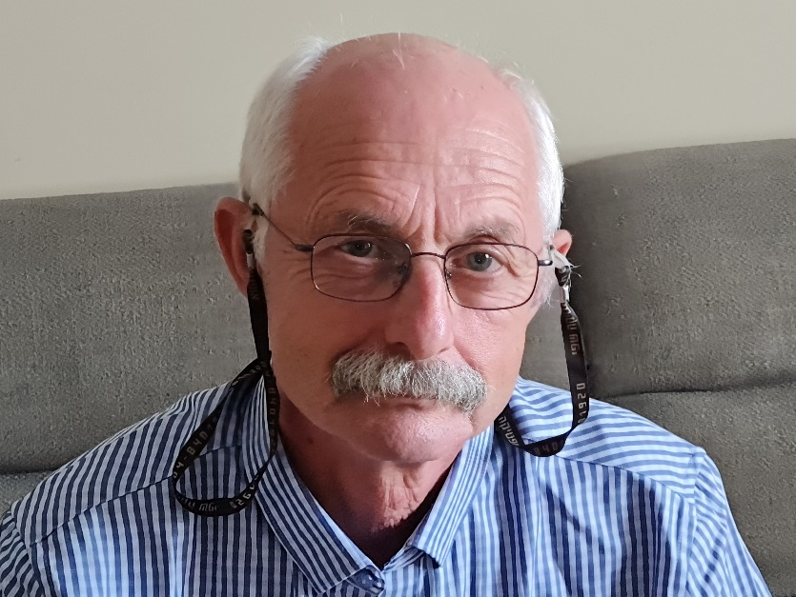

מנהל אגף חשמל בקרה ואנרגיה באיגוד ארים איזור חיפה-ביוב 28 שנים
מחודש יולי מהנדס בחברת א.לוזדרניק בע''מ וחברת על-וסט בע''מ
מהנדס חשמל בודק סוג 3

